**CYCLE-3**

**Mathplotlib**

**Demonstrate creating various types of charts and plots using functions in mathplotlib library**

**1.Sarah bought a new car in 2001 for $24,000. The dollar value of her car changed each year as shown in the table below.**

**Value of Sarah's Car**

**Year Value**

**2001 $24,000**

**2002 $22,500**

**2003 $19,700**

**2004 $17,500**

**2005 $14,500**

**2006 $10,000**

**2007 $ 5,800**

Represent the following information using a line graph with following style properties

* **X- axis - Year**

**Y –axis - Car Value**

* **title –Value Depreciation (left Aligned)**
* **Line Style dashdot and Line-color should be red**
* **point using * symbol with green color and size 20**

Subplot() provides multiple plots in one figure.

***PROGRAM***

*import matplotlib.pyplot as plt*

*import numpy as np*

*xpoints = np.array([2001, 2002,2003,2004,2005,2006,2007])*

*ypoints = np.array([24000, 22500,19700,17500,14500,10000,5800])*

*plt.plot(xpoints, ypoints, '*g',ms = 20)*

*plt.plot(xpoints, ypoints, ':r')*

*leg = plt.legend(title="Value Depreciation ")*

*leg._legend_box.align = "left"*

*plt.show()*

***OUTPUT***

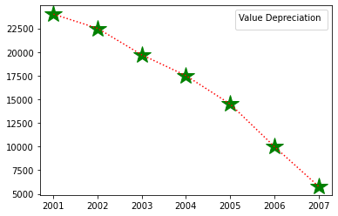

**2.Following table gives the daily sales of the following items in a shop**

|  |  |  |  |  |  |
| --- | --- | --- | --- | --- | --- |
| Day | Mon | Tues | Wed | Thurs | Fri |
| Drinks | 300 | 450 | 150 | 400 | 650 |
| Food | 400 | 500 | 350 | 300 | 500 |

**Use subplot function to draw the line graphs with grids(color as blue and line style dotted) for the above information as 2 separate graphs in two rows**

1. **Properties for the Graph 1:**

* **X label- Days of week**
* **Y label-Sale of Drinks**
* **Title-Sales Data1 (right aligned)**
* **Line –dotted with cyan color**
* **Points- hexagon shape with color magenta and outline black**

1. **Properties for the Graph 2:**

* **X label- Days of Week**
* **Y label-Sale of Food**
* **Title-Sales Data2 ( center aligned)**
* **Line –dashed with yellow color**
* **Points- diamond shape with color green and outline red**

***PROGRAM***

*import matplotlib.pyplot as plt*

*import numpy as np*

*x = np.array(['mon','tue','wed','thur','fri'])*

*y = np.array([300,450,150,400,60])*

*plt.subplot(1,2,1)*

*plt.title("Sales Data1")*

*plt.xlabel("Daya of week")*

*plt.ylabel("Sales of Drinks")*

*plt.plot(x,y,':c')*

*plt.plot(x,y,'Hm',mec='k')*

*plt.grid(color='blue',linestyle='dotted')*

*c = np.array(['mon', 'tue', 'wed', 'thur','fri'])*

*v = np.array([400, 500, 350, 300,500])*

*plt.subplot(1, 2, 2)*

*plt.title("Sales Data2")*

*plt.xlabel("Days of Week")*

*plt.ylabel("Sale of Food")*

*plt.plot(c,v,'--y')*

*plt.plot(c,v,'Dg',mec = 'r')*

*plt.grid(color = 'blue', linestyle = 'dotted')*

*plt.show()*

***OUTPUT***

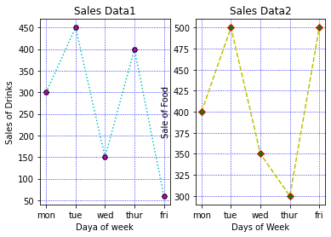

**3.Create scatter plot for the below data:(use Scatter function)**

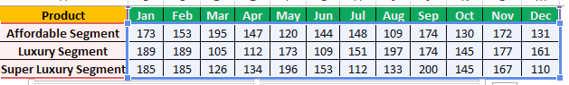

**Create scatter plot for each Segment with following properties within one graph**

* **X Label- Months of Year with font size 18**
* **Y-Label- Sales of Segments**
* **Title –Sales Data**
* **Color for Affordable segment- pink**
* **Color for Luxury Segment- Yellow**
* **Color for Super luxury segment-blue**

***PROGRAM***

*import matplotlib.pyplot as plt*

*import numpy as np*

*plt.title("Sales Data")*

*plt.xlabel("Months of Year")*

*plt.ylabel("Sales of Segments")*

*x = np.array([173,153,195,147,120,144,148,109,174,130,172,131])*

*y = np.array([173,153,195,147,120,144,148,109,174,130,172,131])*

*plt.scatter(x,y, color = 'hotpink')*

*x = np.array([185,185,126,134,196,153,112,133,200,145,167,110])*

*y = np.array([185,185,126,134,196,153,112,133,200,145,167,110])*

*plt.scatter(x,y, color = 'yellow')*

*x = np.array([185,185,126,134,196,153,112,133,200,145,167,110])*

*y = np.array([185,185,126,134,196,153,112,133,200,145,167,110])*

*plt.scatter(x,y, color = 'blue')*

*plt.show()*

***OUTPUT***

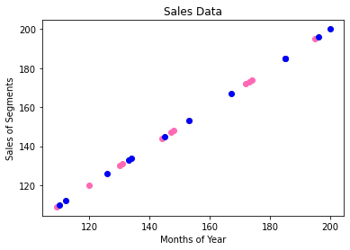

**4.Display the above data using multiline plot( 3 different lines in same graph)**

* **Display the description of the graph in upper right corner(use legend())**
* **Use different colors and line styles for 3 different lines**

***PROGRAM***

*import matplotlib.pyplot as plt*

*import numpy as np*

*x =[1,2,3,4,5]*

*y =[3,3,3,3,3]*

*z =[4,4,4,4,4]*

*plt.plot(x,y, label="line 1")*

*plt.plot(y,x, label="line 2")*

*plt.plot(z,x, label="line 3")*

*plt.legend()*

*plt.show()*

***OUTPUT***

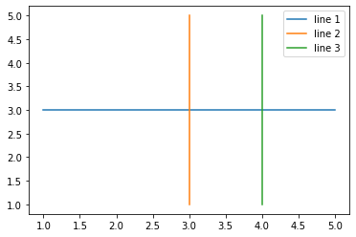

**5.100 students were asked what their primary mode of transport for getting to school was. The results of this survey are recorded in the table below. Construct a bar graph representing this information.**

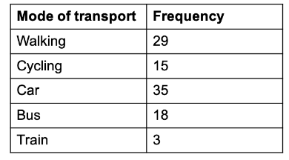

**Create a bar graph with**

* **X axis -mode of Transport and Y axis ‘frequency’**
* **Provide appropriate labels and title**
* **Width .1, color green**

***PROGRAM***

*import matplotlib.pyplot as plt*

*import numpy as np*

*x = np.array(["Walking","cycling","car","Bus","Train"])*

*y = np.array([29,15,35,18,3])*

*plt.title("Transport survey record")*

*plt.xlabel("Mode of Transport")*

*plt.ylabel("Frequency")*

*plt.bar(x,y,color="green", width=0.1)*

*plt.show()*

***OUTPUT***

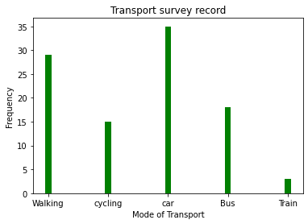

***6.*We are provided with the height of 30 cherry trees.**

**The height of the trees (in inches): 61, 63, 64, 66, 68, 69, 71, 71.5, 72, 72.5, 73, 73.5, 74, 74.5, 76, 76.2, 76.5, 77, 77.5, 78, 78.5, 79, 79.2, 80, 81, 82, 83, 84, 85, 87.Create a histogram with a bin size of 5**

***PROGRAM***

*import matplotlib.pyplot as plt*

*height = [61,63,64,66,68,69,71,71.5,72,72.5,73,73.5,74,74.5,76,76.2,76.5,77,77.5,78,78.5,79,79.2,80,81,82,83,84,85,87*

*]*

*plt.hist(height, edgecolor='red', bins=5)*

*plt.show()*

***OUTPUT***

